Mayer Ingrid Roberta

Group 258/1

University year 2018-2019

Operations Warehouse

Service Oriented Architecture Project Documentation

Summary:

Introduction 3
- Common Library 3
- Warehouse 4
- Operations 4
4.User interface 5
5.Docker 6

Introduction

The business idea of this project is to have a quick overview about the internal processes of a warehouse: to collect the existent information and to be able to use it in a store, to facilitate the internal needs for a better management of the products stock.
The system described in the following pages is successfully exposing the REST services through a web application. Here, the web services are provided by an application server. In this project there exists a number of four services that are run on different instances. This number can be easily extended in the source code, so that the project could be composed from how many services may the user wants to have.
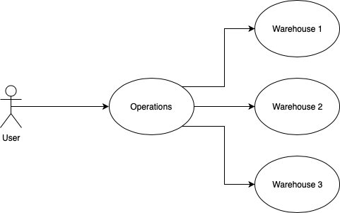
The main idea of the project was to maximise the source code reusage, so that the same source code to be available for different services. As already mentioned, the services exist on different instances; one service is particulary aggregating the collected data from other services.

Common Library

The common library is used so that the same objects could be used in both warehouse and operations module. When a change in the source code overcomes, the change will be available in all modules that are using the library. The common library contains two classes: Product and Products. The Common Library is used in order to make the domain objects available for the other services. The Product class contains the name, price and quantity of a product. The Products class is a wrapper of a list of products. It’s purpose is to facilitate the serialisation and deserialisation of objects of the operations between modules.
Figure 1.1

The Products class contains a list with the objects of the Product class:- objects that have a name, price and quantity as attributes. The following diagram contains the internal structure of both classes:

Warehouse

In the Warehouse, the storage of the products is being made in the ProductStorage class. The getter method of the products, as well as the methods incrementQuantity, updatePrice and addProduct are available in ProductStorage class:
- The method incrementQuantity(), a new quantity for the product is being set.
- The method updatePrice(), a new price is replaced with the old one.
- The method addProduct() adds a new product to the product list.
In WarehouseController class
Figure 2.1

Additionally, the ProductStorage class holds a list of the products that are stored in memory. The operations that can be done in the warehouse are defined in WarehouseController.

Operations
The Operations module has its main role to aggregate the information of the warehouses. The methods were created after the business cases that arrive inside a store management:
- Return the products of the warehouses
- Return the products of one specific warehouse
- Return the sum of the products
- Return the quantity of the products
- Return the products that are in low stock
- Return the product that is in the lowest stock of the warehouse
- Return the product that has the maximum stock in a warehouse
- Return the maximum quantity of the products in a warehouse
- Return the maximum price of the products in a warehouse
- Return the minimum quantity of the products in a warehouse
- Return the minimum price of the products in a warehouse
This application makes calls to other servers and each method describes an endpoint.

Figure 3.1

4.User interface

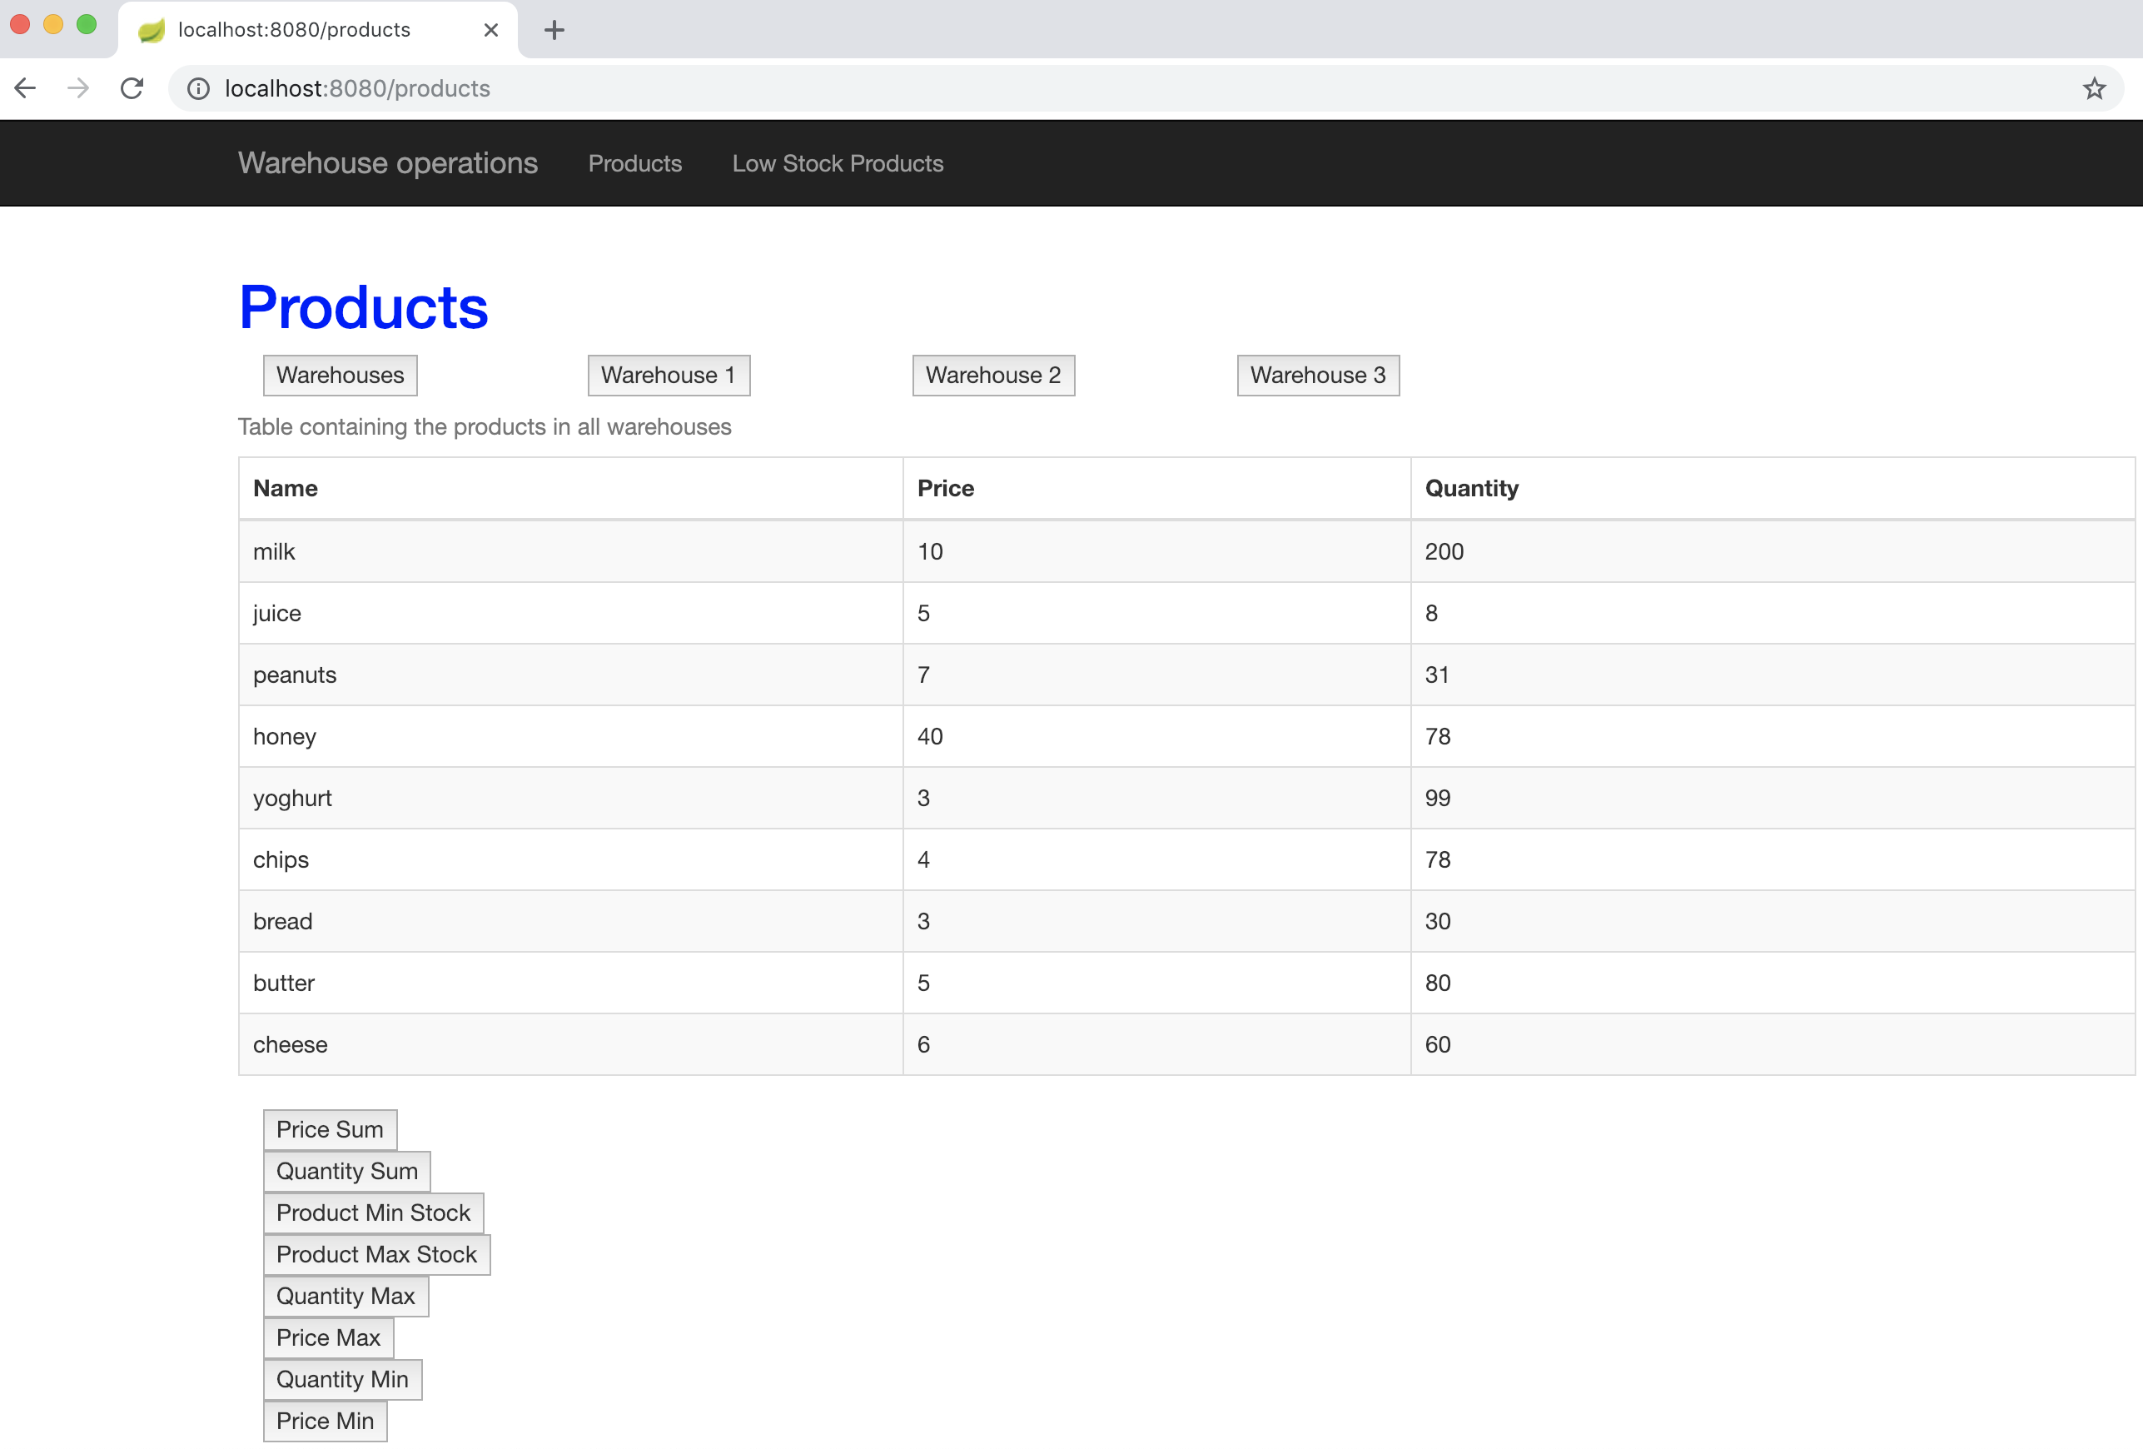
The user interface was created with Thymeleaf. In controller the values for the user interface are set so that every method will return the page that should be printed.
Figure 4.1

localhost:8080/products: Here, the warehouse operations are being shown. The operations can happen on three different warehouses: Warehouse 1, Warehouse 2, Warehouse 3 and Warehouses - it contains all the products available in the three warehouses. Depending on the warehouse chosen, a list of the products available in the warehouse is being shown: for every product a name, price and quantity is being displayed. Afterwards, depending on the button clicked - the functionality of the Operations module are displayed: calculate the sum of the prices, calculate the sum of the quantities, show the product that has the minimum stock, show the product that has the maximum stock, show the maximum quantity, show the maximum price, show the minimum quantity and show the minimum price.
localhost:8080/lowstock - is the page where a list with the products in the low stock are being displayed.
localhost:8080/ - is the welcome page of the application.

5.Docker

The Docker is used to prepare the application artifacts for deployment. For every module of the application a docker image is created using its jar and a corresponding container is started. Using docker compose, the system is started having the four components described above.
- Operations is mapped on port 8080
- Warehouse1 is mapped on port 8081
- Warehouse2 is mapped on port 8082
- Warehouse3 is mapped on port 8083

